GDS diagnostics (Ref Apr 2009 GDS101)

How to use this guide: Follow the questions until you reach a conclusion. In following contact with service personel quote the reference above and which point you got to. This will allow the personel to find out what you have done so far. In addition to this it is always required that you send the serial number of the cabinet. And screen shots of screen 11 and 12. This will allow us to recomend parts and dealers with the first contact. Depending on the error and age of the unit SKIPPER will send parts or an exchange unit. In many cases it may be possible for the vessel to change the parts themselves. The last page of this guide is a form used to ensure a quick and efficient service. Please include this information in the first contact. Send in email to support@skipper.no

Tools required. Multimeter, Digital camera, Oscilloscope (for suspected transducer problems)

Problems tackled in this guide :
IO power reduction, Bad bus cable, bad CPU - NMEA, black screen (bad Inverter), Bad terminal card (power pack), bad battery, lost settings, bad memory. Fix range setting

Note: To get to screens above screen 3 you need to press the menu button and turn the encoder at the same time
- Is screen blank / Not booting fully?
Yes every time – go to section 1.1
Yes intermittently – go to section 1.2
- Is the system rebooting by itself?
  - Yes – go to section 2.1
- Is there problems with the inputs or outputs?
  - Is the problem NMEA? Go to 3.1
  - Is the problem analogue out Go to 3.2
  - Is the problem Digital pulses in? Go to 3.3
- Is the system having problems detecting the bottom?
First – Check Fix range on screen 9 is OFF
  - Is this constant problem / Constant in deeper water? Go to 4.1
  - Is this intermittant depending on speed? Go to 4.2
  - Is this intermittent depending on vessels position/water type? Go to 4.3
- Cannot get to or change menus
Have you tried to push the button (menu or softkey) AND turn the encoder at the same time?
Yes – Have you checked the function is available in the manual? (Some functions may require special actions (hidden button))
Yes - may be keyboard or encoder malfunction – continue to next question
- Is there the keyboard or encoder malfunctioning?.
  - Encoder? Go to 5.1
  - Key(s)? Go to 5.2
- Does the system loose its settings?
  - Yes – Does the unit beep 4 times on startup?
    - Yes - Go to 6.1
    - No – Versions pre 08300 Sw before 5.05.XX
Does the status screen say bad memory?
      - Yes go to 6.2
      - No – Contact Skipper
    - No – Versions after 08150 SW from 5.05.XX go to 6.3
  - No – Has software been upgraded recently – sometimes software upgrades can reset the memory. Try changing the settings and restarting. If this does not work go to 6.3.
- Is the Alarm behaving correctly
  - No – Go to 7
- Is the screen too bright by new standards or the latest NMEA formats not available? – Check the software is version > 5.05.06
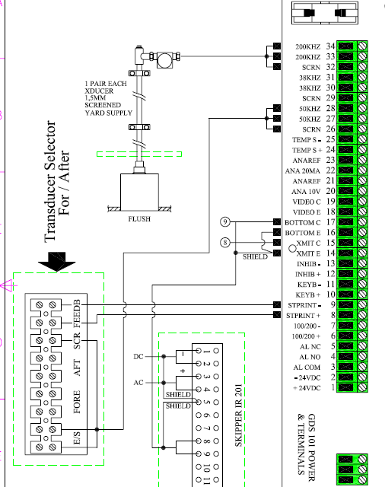

For more diagrams check Appendix

Section 1, Screen, Inverter or cabling problems.
  - If you look at an angle do you see text on the screen?
1.1.1 Yes –
Inverter problem – turn off, wait at least 20 seconds, turn on again. This will probably solve the problem. (the inverter can get confused if the power is glitched fast. Some power is stored and that is enough to mess it up.)
Did that work? – No, Invert or backlight need changing – Contact SKIPPER
1.1.2 No – Go to 1.2
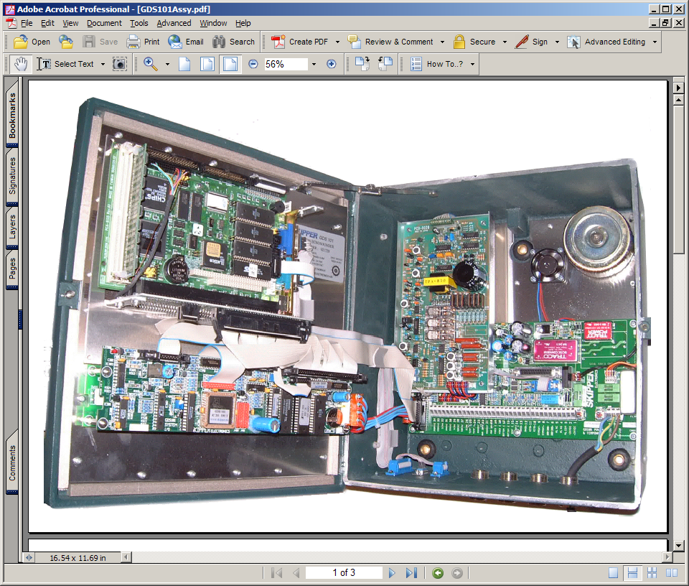
CABLES
  - If you connect a screen to XCN6 do you see the screen?
1.2.1 Yes
– The CPU appears to be failing, but check the cables take out and re-seat the large cable on the rear of the motherboard.
1.2.2 No
– The CPU is not booting. Take out the CPU from its slot, clean the contacts, and replace. Do the same with the Connecter on the rear of the Motherboard.

Did this work?
1.2.2.1 Yes – if the serial number of the unit is 05-07, it is recomended to change the motherboard and cable on the rear. Contact SKIPPER for parts ZZK-01081, and ZZZ-XXX
1.2.2.2 No - When restarting, do you get anything on the screen?
1.2.2.2.1 Yes- Is there a boot error?
Check the battery voltage on the battery on the CPU card with the power off is it > 12.7V. Under 3.0V we recommend to change, but this may not be problem.
If less, change the battery (if available , if not unit will loose settings on restart.), set up the bios as in appendix 1, or in manual.
Check the bios of the system is correct in accordance with the the correct BIOS settings in appendix 1, or in manual.
Otherwise the problem could be in IO card – change IO card. Please quote which you have in your unit.
1.2.2.2.2 No – Fault probably in CPU - Contact SKIPPER for replacements
- Section 2, Error on CPU modules
2.1 Is the power supply correct on the terminal board J400 , and the voltages displayed on the status screen in black >4.7 and >11.3/22.5?
2.1.1 Yes - Goto 1.2.2.
2.1.2 No – If < 11.3V, Disconnect Power cable at J 500. If now >11.3V Change IO pcb (IC 500 Short Circuit)
2.1.3 No – If >11.3V Change the terminal card. (probably component failure on Rxxx)

Test points for voltage. J400
- Problems with inputs and output:
  - NMEA Problem. (Check you have connected as in diagram in appendix 2**)

Drawing of loop on connector
– Do you see the NMEA output on the Com screen (screen %??) in output mode?
3.1.1Yes
– Remove NMEA outputs and loop back XJ303 pins 4,5 to 1,2 and 6,7 to 8,9 Do you see the output coming into the input com port (change the display to ’display input’)?
3.1.1.1 Yes –
You have a problem with the cabling out side of the unit.
3.1.1.2 No –
Problem with the Terminal card contact skipper for a replacement
3.1.2 No- Com screen (screen 8) are the outputs turned

3.2 Analogue out-
Set the demo mode on (Screen 9) measure point J100 p 20,21 is there a voltage?
J100 p22,23 (current thrrough a ca. 370 ohm resistor ) is there a current?
3.2.1 Yes, if it is correct for the present speed then problem is external cabling/ system.
Yes if it is wrong, remove the connections and measure again, if it is still wrong Check you settings for max and min, and that you are measuring voltage instead of current.
Yes, if you’re setting is current (4-20mA) measure current instead.
3.2.2 No, Check the settings are correct on screen 9 if these are active then ****..... contact support@skipper.no
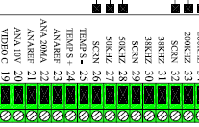

J100

  - Digital pulses. (Check you have connected as in diagram in appendix 3**)
Is the problem speed (Pulse) input?
3.3.1Yes – Are the other speed indicators working correctly?
3.3.1.1 No. - Problem is in cabling or speed log
3.3.1.2Yes – Is the Speed wrong relative to the speed log?
3.3.1.2.1 Yes – Check the pulses per NM is set correctly at both ends, if this is correct, go to 3.3.1.2.2
3.3.1.2.2 No - check the cabling and the voltage of the pulses (should be ??1.5-6V?? Length greater than 50 ms) If all is correct change the ?? terminal card??
3.3.2 No – Problem with the pulse output?
3.3.2.1 Yes – Check the manual/version of the system that the function is available. Later versions use INHIB ?? as power failure alarm
      - No – Problem with Alarm settings? Go to 7.1

- Problems with bottom detection (IMPORTANT If you do not have a standard SKIPPER transducer, check max allowable power before increasing the power level)
4.1 Problem is constant in deeper water –
Is the actual depth within the following ranges (Power level at 100%) ?

Transducer Frequency | Present Depth less than
38 kHz | 1600m
50kHz | 1000m
200 kHz | 200m
4.1.1 No – The system is probably out of range. Check once within range. In some water conditions the range can be reduced. Check in other water. If still no improvement continue with 4.1.2
4.1.2 Yes – Check the Xcvr voltage on status screen, check the power level they should be as follows

Power Level | transceiver Voltage  (pulses lower)
100 | >40V
75 | >30V
50 | >20V
25 | >10V
10 | >4V

If correct check also test point XX on Transceiver (similar voltages should be present )

Are the voltages correct?
4.1.2.1 No. Replacement IO card required. (This fault may qualify for an exchange unit, contact SKIPPER.)
4.1.2.2 Yes. Check with full power
Possible problems-
- Transducer not in water – If gate valve lift and re-seat the transducer. If in SKIPPER tank check the resistance and then send a diver to inspect (sorry!) some non standard tanks may allow you to release air.
- If ice tank is in use the air can be bled by loosening the top of the pipe.
- Transducer failure
- Disconnect and measure the resistance of the transducer should be
Picture of waveform
If open circuit the transducer is probably damaged. If two transducers present try swapping.
  - Set the output power to 10%. With an oscilloscope, Measure the voltage on the terminal to the sensor. Measure from + terminal to the gnd terminal. Do you see a distorted square wave with approximate amplitude 55V??
4.1.2.2.1 No, If you do not have this. Remove the transducer and measure again. If still not present or very weak
Change transceiver board part PC-?????
4.1.2.2.2 Yes
Contact SKIPPER

5 Keyboard problems
Mounting of encoder cable
5.1 Encoder problem - Is problem intermittent? (Now and then)
5.1.1 Yes – Check no damage to cable and it is correctly placed (can be mounted wrongly) See diagram??
5.1.2 No Constant - Encoder not working – Check Cable is correctly placed – if so replace keyboard
5.2 Keyboard Problem – Is it just 1 button or more
5.2.1 just 1 button – Check manual that button is available. If available, Check you cannot turn the encoder with the button pressed to change the value. If not move to 5.1.
5.2.2 Many buttons Remove clean and reseat the cables attached to the keyboard and the large cable from IO card to motherboard. If this does not work replace keyboard.

6 CPU, memory or batteries
6.1 unit beeps 4 times on startup. Check the jumper JP101?? should be i ?? left postion. If correct measure voltage on the battery (When unit is turned on) should be greater than 3v. If below 2.7V replace.
If problem not solved:
6.2 Bad memory on PCA 6135:
Check the memory is seated correctly. Try removing and replacing memory blocks (SIMM/DIMM)
6.3 Bad memory on PCA 67XX:
Take out and reseat the Compact flash on the rear of the CPU card. Change some values and recycle power to see if the values are kept. If this does not help contact SKIPPER
7 Alarm I/O
Is the alarm correctly activated. And showing alarm on screen. (Check max and min alarm and that alarm message is flashing on screen)
7.1 Is the problem with internal alarm?
7.1.1 Is the buzzer activated? (Alarm function on screen 9 status screen).
      - Yes - The buzzer on Terminal card is failing. New terminal card is needed or fix an external buzzer on alarm.
      - No - Activate the buzzer on screen 9

7.2 Is the problem with the Relay (system) alarm – measure with continuity tester over J100 pin 3& 4 (Normally open) or 3 & 5 Normally closed
Is this correct
7.2.1 Yes , problem is with cabling/ Central alarm unit
7.2.2 No , try reseating the cables to the Terminal board Particualrly the bus to the IO board, try reseating the Large cable from IO to motherboard. If this does not solve problem change terminal board, get an IO board as reserve.
  - Is the problem with the power failure alarm or alarm reset?
    - Yes - Is the alarm connected as per appendix 3. (power failure alarm is not contact closure, but a digital alarm)
      - Yes, Is the software greater than version 5.04.??
        - Yes, reseat cables. – contact SKIPPER
        - No , Upgrade the sftware this function will only work from version ??
      - No – reconnect correctly and check software is correct.

Appendix 1 - To follow
BIOS setups for CPUs
Pre 6135
6135
6753
6740
6742
Appendix 2 setup of NMEA
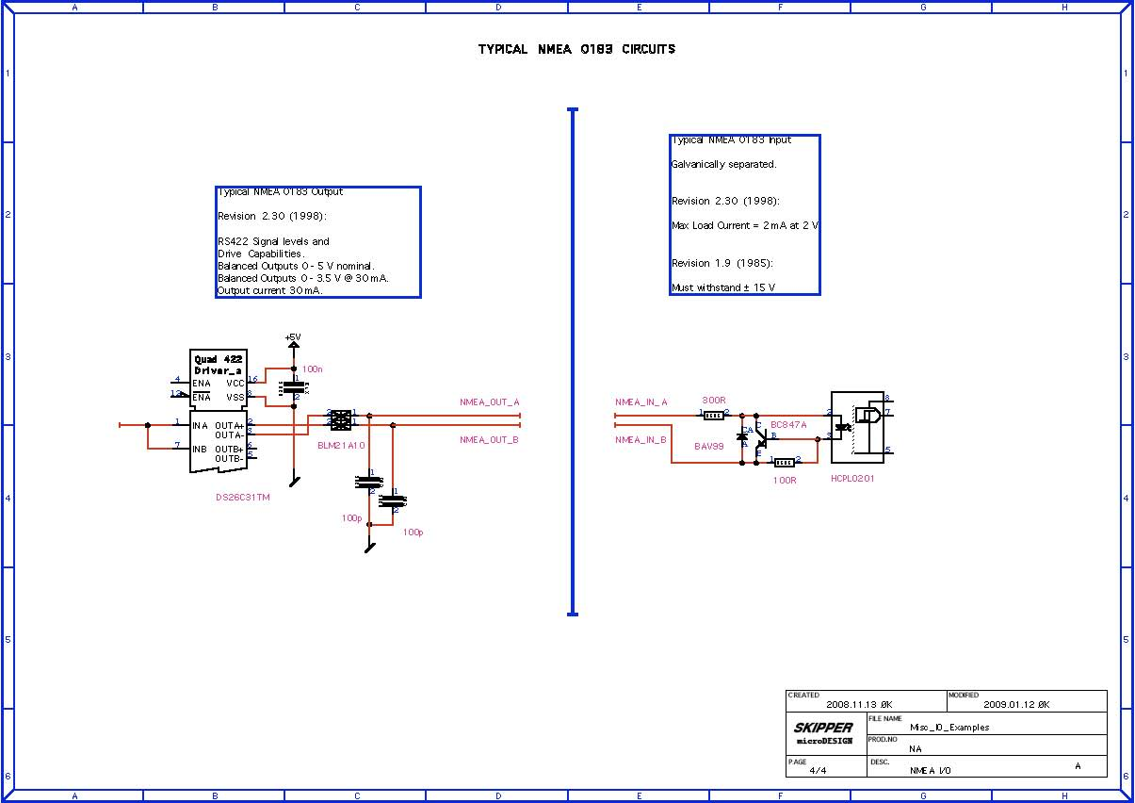
Appendix 3 setup of Pulse - To follow

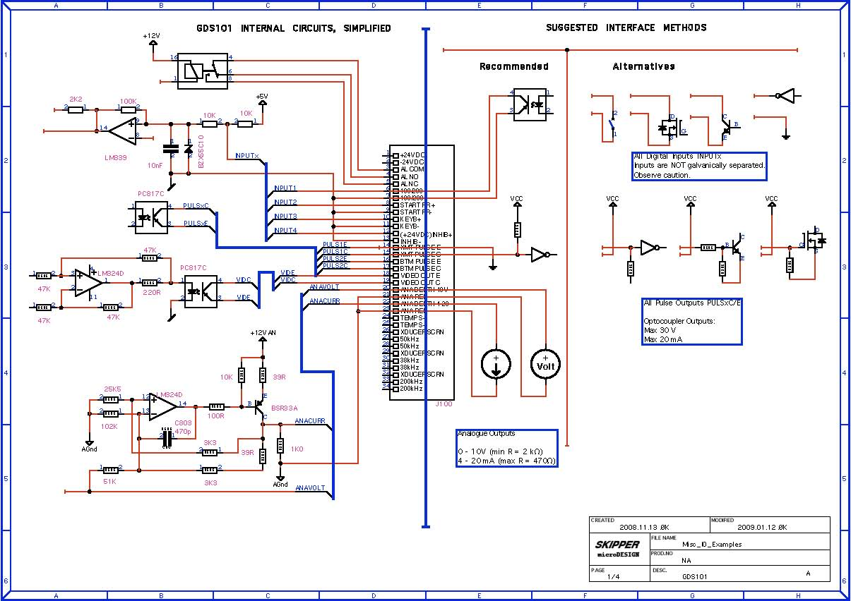
Appendix 4 Various diagrams for help with diagnostics
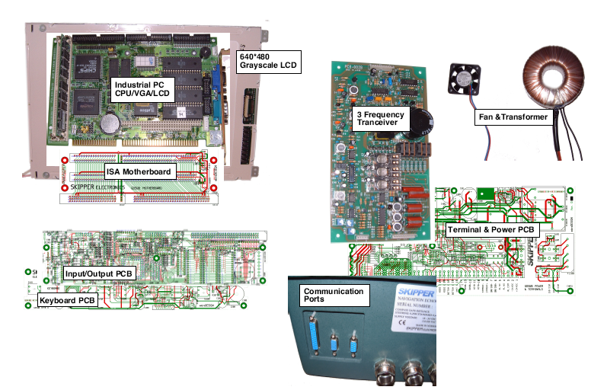
Wiring
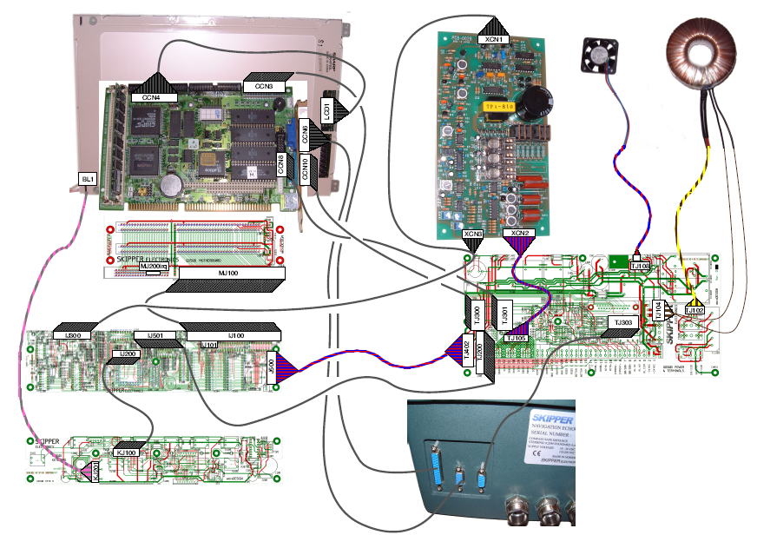

Information to be sent to a support centre if new spares or help is required. (This will allow us to check your diagnosis and ensure you get the correct version of part for your generation of cabinet)
SKIPPERid: |  | Company:
System type: |  | Contact name:
Serial number: |  | Contact address:
Vessel name: |  | Next port /date (give us at least 4 days notice if a main shipping hub, 7 days difficult to deliver)
Bought from:  (company) |  | Delivery address:
Approx. Date of purchase/ installation (guarantee?) |  | Original purchase number (if availalble)
What is wrong:
What were conditions when the error occured? (ice, High seas, depth, dock, open sea?)
What have you done?
(Diagnostic number?)
www.skipper.no
Do you require service or parts/ instructions: |  | Have you attached pictures of Status and Scope screen (Showing defect channels)

